326. Power of Three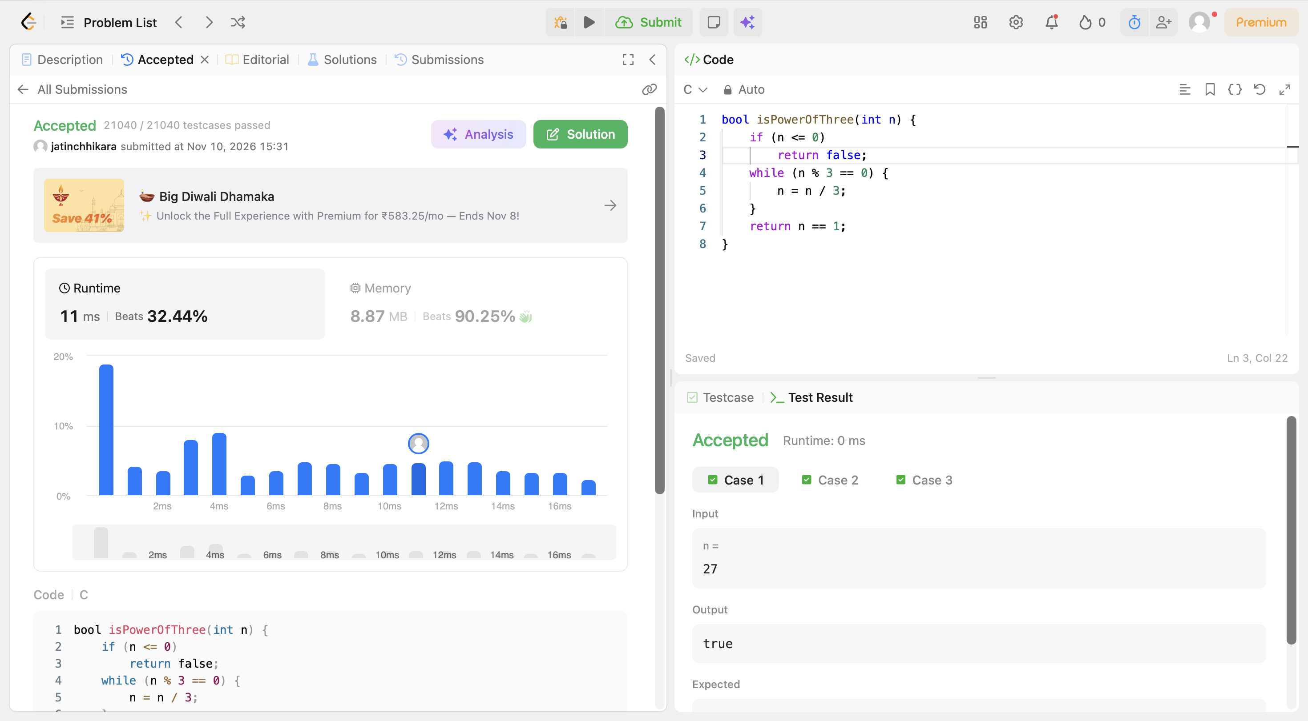
Code:
bool isPowerOfThree(int n) {
if (n <= 0)
return false;
while (n % 3 == 0) {
n = n / 3;
}
return n == 1;
}

